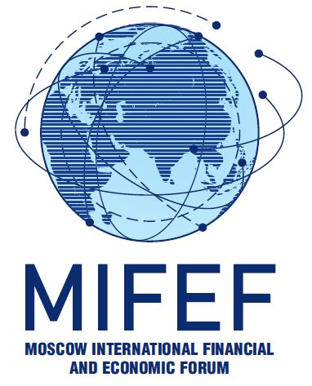

VIII MOSCOW INTERNATIONAL FINANCIAL AND ECONOMIC FORUM

« BUILDING BRIDGES, NOT BARRIERS:
BUSINESS EURASIA IN A NEW REALITY»

November 18, 2021 Moscow

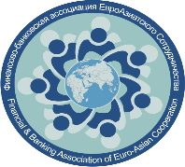
ORGANIZER
FINANCIAL & BUSINESS ASSOCIATION OF EURO-ASIAN COOPERATION
WITH SUPPORT OF
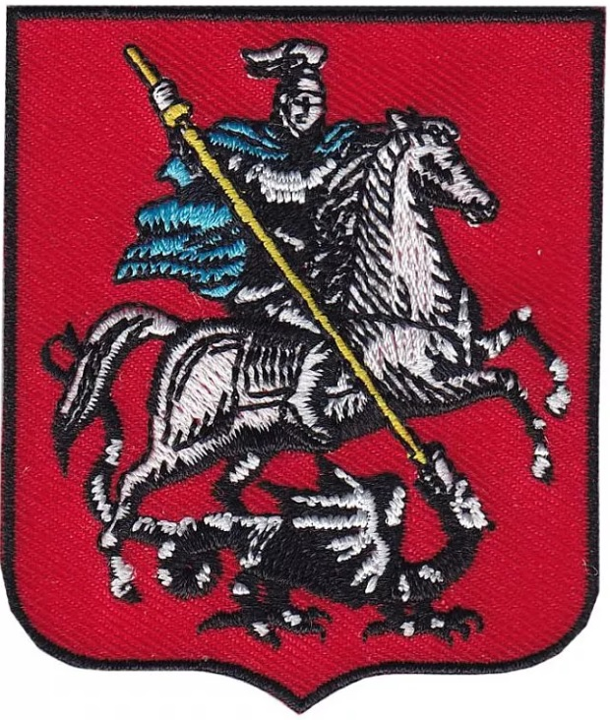
Department for External Economic and International Relations of Moscow

The Russian Union of Industrialists and Entrepreneurs

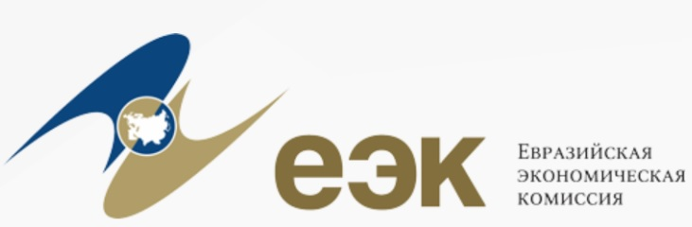
Eurasian Economic Сommission

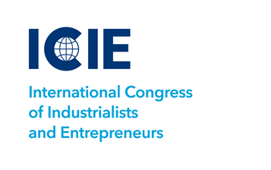 | 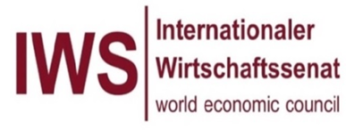

PROGRAM

18.11.2021  09.30 – 10.00 | Registration of the Forum participants, welcome coffee  Address: 5 Smolenskaya street, Moscow, 119121 Russia, Golden Ring Hotel
10.00 – 12.00 | Plenary meeting  «BUILDING BRIDGES, NOT BARRIERS: BUSINESS EURASIA IN A NEW REALITY»
Questions for discussion: Is the era of globalization ending? Can regional associations become an effective alternative? Centrifugal and centripetal trends in Greater Eurasia – what will prevail? How does the pandemic factor work? Can the union of the EAEU and the SCO become the engine of innovative development in Eurasia? Can we talk about the decline of Western European integration? National priorities and regional cooperation. Using the potential of regional blocks for national development. The role of China, India and the EAEU in ensuring the economic recovery of Eurasia. Do the Eurasian development banks and other multilateral banking institutions serve as catalysts for sustainable economic growth?

Opening speech: Alexander Murychev – Chairman of the Executive Board of FBA EAC, Vice-President of RSPP, Doctor of Economics, Professor (Russian Federation)

Мoderator: Alexey Gromyko – Director of the Institute of Europe of the Russian Academy of Sciences, Corresponding Member of the Russian Academy of Sciences, Professor of the Russian Academy of Sciences (Russia)
Invitees:

Alexander Shokhin – President of the RSPP, Doctor of Economics, Professor (Russia)
Artem Chaika – President of the International Congress of Industrialists and Entrepreneurs (Russia)
Evgeny Primakov - Head of the Federal Agency for CIS Affairs, Compatriots Living Abroad and International Humanitarian Cooperation
Kairat Kelimbetov – The Chairman of Agency for strategic planning and reforms of Republic of Kazakhstan, Governor of
Astana International Financial Centre

Mikhail Myasnikovich – Chairman of the EEC Board
Nikolay Podguzov – Chairman of the Management Board, Eurasian Development Bank (EDB)
Pascal Lorot – Special Representative of France for Central Asia, Doctor of Economics and Politics (France)
Representative – International Economic Senate, Founder, Partner (Germany)
Sergey Cheremin – Minister of the Government of Moscow - Head of the Department of Foreign Economic and International Relations of the City of Moscow (Russia)
Tadzio Schilling – General Director of the Association of European Businesses (EU)
Zhang Hanhui – Ambassador Extraordinary and Plenipotentiary of the People's Republic of China to the Russian Federation
Representative – International Economic Senate, Founder, Partner (Germany)
12.00 – 12.30 | LUNCH
12.30 – 14.30 | I panel  «DIGITALIZATION OF INDUSTRY – TRANSITION TO A NEW ERA OF INDUSTRIALIZATION»
Discussion topics:
- industry 4.0 as a concept for the development of Eurasian cooperation;
- introduction of digital technologies in the tasks of managing industrial enterprises of the countries of Eurasian cooperation;
- the role of digital technologies in the automation of production processes;
- introduction of industrial robots-a fashion or a real need;
- digital technologies as a strategic direction for improving the efficiency and safety of labor at industrial enterprises of the countries of Eurasian cooperation.

Moderator: Alexander Kotlyarsky – First Vice-President of the FBA EAC, General Director of PROMTECH LLC, Doctor of Technical Sciences, Professor (Russia)
Invitees:

Alexander Poznyakevich – Business Development Manager of Kaspersky Lab (Russia)
Alexey Samoshilov - Head of the business unit "Industrial Service" DI CS of SIEMENS (Germany)
Andrey Polyakov - General Director of Soyuztechnocom JSC (Russia)
Arman Shakkaliyev - Member of the Board – Minister in charge of Competition and Antitrust regulation
Glyn Jones – CEO of Trolex Group, an associate member of ABMEC (Great Britain)
Matti Yarvinen – Vice President for Automation of Metco-Oytotek (Finland)
Oleg Lettiev - Director of the Department of PROMTECH (Russia)
Dmitry Tausenev - Director of Sympatec GmbH Representative Office (Germany) in the Russian Federation, CIS countries, Baltic States and Mongolia
12.30 – 14.30 | II panel  «MONETARY AND FINANCIAL SUPPORT FOR CROSS-BORDER PARTNERSHIP»
Discussion topics:
- growing role of international development banks in cross-border finance and investment;
- payment and settlement services for international cooperation: looking ahead;
- digitalization in the currency sphere – problems and prospects;
- financial centers of Eurasia yesterday,today and tomorrow;
- ESG-banking: new opportunities or obstacles on the path of Eurasian cooperation?

Moderators: Oleg Preksin – Member of the FBA EAC Board, Vice-President, Member of the Council of the ARB (Russia)

Invitees:

Andrey Bokarev – General Director of the Eurasian Regional Center of the NDB
Borislav Ivanov-Blankenburg – Chairman of the Management Board, Deutsche Bank Ltd., Russia
Denis Ivanov – Chairman of the Board of the International Bank for Economic Cooperation
Dmitry Pankin – President, Chairman of the Board of Directors of the Black Sea Trade and Development Bank
John Mulligan - World Gold Council's Climate Change Lead (UK)
Kirill Zhukov-Yemelyanov – Chairman of the Management Board, UniCredit Bank
Nikolay Kosov – Chairman of the Management Board, International Investment Bank (IIB)
Sergey Dubinin – Member of the Board of Directors of JSC BTB Capital
Sergey Storchak – Senior Banker of VEB RF

12.30 – 14.30 | Panel III  «TRANSPORT AND LOGISTICS CORRIDORS ARE THE INFRASTRUCTURE FRAMEWORK OF THE GREATER EURASIAN PERTNERSHIP»
Discussion topics:
- development of the Eurasian transport and economic corridors as an important factor in strengthening trust and security in the Eurasian space;
- new transport corridors in Eurasia from the point of view of the most important logistics agents (China, the EU, Russia, the EAEU, India, Iran, Pakistan, the Middle East);
- current and upcoming market changes due to the use of multimodal supplies of goods, the creation of connected logistics and economic spaces;
- modernization of railway and road infrastructure in Eurasia.

Moderators: Vladimir Kotenev – Member of the Board of the FBA EAC, Managing Director of Euroasian Strategic Consulting GmbH (Germany)
Uwe Leuschner – General Director of the Economic Club Russia/Germany (Germany)

Invitees:
Alexey Grom - President of the United Transport and Logistics Company (Russia)
Anatoly Tkachuk - President of the FBA EAC, President of RUSTITAN Group of Companies, Member of the RSPP Board (Russia)
Armen Harutyunyan - Director of the Agro-Industrial Complex Department of the Eurasian Economic Commission
Askar Salymbekov – Honorary President of the Dordoi Association, member of the Supervisory Board of the FBA EAC
Gennady Bessonov - Secretary General of the Coordinating Council for Trans-Eurasian Transport (Russia)
Hirofumi Arai – Director of the Department of Analysis and Research, Chief Researcher of the Scientific Institute of Economics of Northeast Asia (ERINA), Niigata, Japan, Honored Professor of the Institute of Economic Research of the FEB RAS (Russia)
Ohashi Iwao - Advisor for Japan and the Asia-Pacific countries of the Association of Industrial Parks of Russia, Member-expert of the Transport and Logistics Subcommittee of the RSPP International Cooperation Committee
Ulf Schneider - Member of the FBA EAC Supervisory Board, President & Founder of the SCHNEIDER GROUP (Germany)
Viktor Fokin – General Director of ENERGOSERVICE LLC

